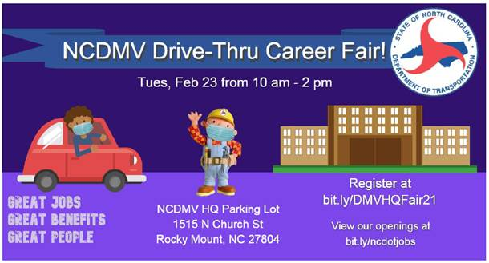
Did you know the NC Department of Motor Vehicles has recently relocated its headquarters to Rocky Mount? We are excited to have them here locally as a great new neighbor and community partner!

There are a substantial number of employment opportunities with the NCDMV throughout the state and especially here at the new headquarters tower.
>> Opportunities are available for rising graduates and alumni from any major.

Check out the following resources to explore career opportunities!
- NCDMV Drive-Thru Career Fair – Tues, Feb. 23rd from 10am – 2pm. Click here for details and registration.
- Which DMV HQ Unit is Right for Me? - Click here
- The Insider’s Guide to Getting Hired by NCDOT - Click here
- NCDMV Jobs Quick Reference Guide - Click here

Important Tips…
- You may notice some positions are marked as “temporary”. Do not be dismayed by this as, in many cases, the intention of the DMV is to transition these into permanent roles. (Having positions start as temporary allows for a streamlined/quicker hiring process on their end.)
- When applying for government positions the most important aspect is putting ALL of your relevant knowledge, skills and abilities into the actual application. While you will still want to upload your well-written and targeted resume, be aware that the first few levels of screening will likely only include a review of the information input into the actual application. In that review process, human resources professionals (and sometimes automated computer systems) will be scanning for keywords and experience (no matter whether they are paid or not) that match the job posting as closely as possible. You can copy/paste some of this from your resume but don’t let the standard-length limitations of a resume also limit what you put in your application – it is almost impossible to list too many details or too much experience in the actual resume for government positions. Applying this tip is crucial to getting through the screening process!

Jessie W. Langley, M.S.Ed.
Associate Dean of Career Development & Leadership
––––––––––––––––––––––––––––––––––
p: 252.985.5177
f: 252.985.5580
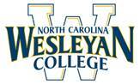
3400 N Wesleyan Blvd. | Rocky Mount, NC

